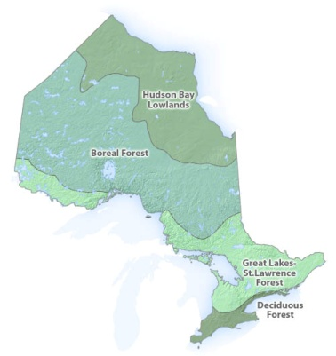
Species at Risk Assignment
“Divide and Conquer - Learn and Share” Quick Study In-Class Assignment

http://www.mnr.gov.on.ca/en/Business/Species/2ColumnSubPage/276503.html
http://www.rom.on.ca/ontario/risk.php?region=4

We live in the Great Lakes – St. Lawrence Forest Region.

Click on / go to the links, above.
Select one of the Species at Risk based on your “criteria” (… a GOOD one – get it approved by your teacher)

Common Name of Species

Physical Description of your Organism

Provide a picture…
What is the Endangered Status?

Where are they presently found (geographically)?

What are they threatened by?

How are they being protected?

Share any other wild, wonderful, weird, but TRUE information about your species:

