E.D.G.E.
Environmental Duty for a Greener Environment
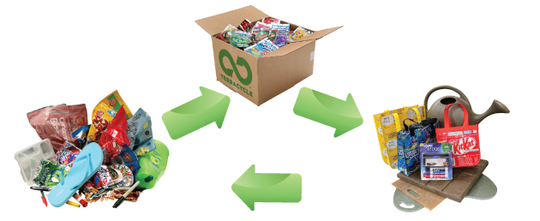

Is working with Terracyle to
- reduce landfill waste,
- repurpose waste into new products, and
- raise money for Bluevale’s environmental initiatives.

